Bettina Gröber
Freiburg Write Consultant Training 2018/2019
Thesis

Healing writing as a specific application of writing to learn strategies

Structure

- Definition, characteristics and aims of ‘healing writing’ as a form of creative writing

- Instruments and methods: Examples for an individualized, resource-based use of writing to learn in the field of ‘healing writing’

- Writing to learn as a way to explore person and personality: An impulse for further elaboration of ‘healing writing’ instruments by aspects of non-directive writing consulting

- Bibliography

- Definition, characteristics and aims of healing writing as a form of creative writing
‚Healing writing‘ can be defined as a specific form of creative writing which focuses on the writing process as a way to explore and revise anything concerning personal experiences, thoughts or feelings. The intention of ‘healing writing’ thus is to offer a medium for reflection in order to provide new, deeper or “better” insight into personal questions, circumstances, problems, and other. Healing writing in this way can also be described as a very personal and individual form of writing to learn: During and through the process of writing, the writer can acquire knowledge in any field that is of interest or concern for her or him.
While in English-speaking countries the use of language and writing in a thus defined therapeutic way is relatively well-established, the German-speaking area still is on the move to discover the positive effects of writing for people’s health or well-being. It is interesting for example to review the therapeutic offers and services of psychosomatic clinics in Germany: One can usually find programs involving visual or musical arts such as painting or pottery, singing or practicing instrumental music – but the number of clinic offering courses or groups for therapeutic writing is substantially lower.
Even if it is true that, as James W. PENNEBAKER states, “the scientific research surrounding the value of expressive writing is still in the early phases”, different sciences, among them writing theory, as well as evidence from practical use have discovered a number of “approaches to writing that have been found to be helpful”. PENNEBAKER himself has researched widely and deeply the healing potential of writing not only for mental, but also for physical health and well-being. Looking at behavioral changes, the effect of expressive writing on the working memory is the most interesting with regard to the perspective of writing theory: the healing potential of expressive writing according to PENNEBAKER, who refers to the findings of KLEIN & BOALS (2001), can also be seen in the fact that expressive writing offers possibilities for dealing with difficult feelings and thoughts – and thus increases the capacities of working memory.
As writing as an instrument or strategy of healing offers a way “uns in allen Bereichen zu erforschen”, healing writing can also be described or defined as a specific form of writing to learn. Thus there are also many techniques and methods which are generally used for writing to learn purposes that can be and are especially applied in the field of healing writing.
The present text explores this specific relevance of writing to learn. To do so, some of the most important, appropriate and practiced techniques, methods and strategies are introduced and discussed regarding to their theoretical foundation in writing theory as well as to their practical use. The focus thereby lies on the high level of authenticity and individuality writing to learn facilitates: the application of writing to learn instruments opens up ways to achieve knowledge about and insight into individual experience, person and personality of the writer.
Absolving the Freiburg Write Consultant Training 2018/2019, the author of the present text concludes her article with some acknowledgements on possible perspectives for a further mutual exchange and influencing between healing writing and writing consulting.

- Instruments and methods: examples for an individualized, resource-based use of writing to learn in the field of healing writing
With writing being a highly individual form of articulation and communication, it is not surprising that psychology and psychological treatment have “discovered“ it as a mode of working on health and healing – although it is not yet as established as other creative genres such as painting, making music or expressing oneself by means of movement therapy (compare introduction). Writing exercises are not only recommended in order to express personal feelings and thoughts, but also to reflect them: by writing down what is going on in one’s own mind and heart – whether in a private, self-managed way or practiced in a therapeutic setting – , by thinking about and rethinking events and experiences, the writer gets the chance to acquire further and deeper insights. To make this possible, the adequate, individualized and resource-based application of strategies, methods and techniques of writing to learn seems to be expedient: the advisor (therapist, coach, etc.) can offer a variety of means different exercices and stimulations which he or she thinks they could suit the individual client.
The following paragraphs describe several examples for the use of writing to learn in the field of ‚healing writing‘ and thus demonstrate the special benefits, but also limitations of the related strategies, methods and techniques: writing to learn helps people help themselves by offering instruments for self-reflection and individual as well as independent, self-aware knowledge acquisition. But it is especially this focus on self-responsibility which points out aspects that should not be neglected concerning writing to learn in contexts of ‚healing writing‘. The first aspect refers to the importance of personal motivation of the writer: writing to learn will only work as intended if the writer or client is open to experiences and experiments that may be quite new, disconcerting or even frigthening to him or her. Otherwise, the „confrontation“ with writing to learn exercices may cause refusal – not only refusal to write, but maybe even refusal to reflect thoughts, feelings or experiences in general. Care should also be taken, second aspect, if the client is motivated, but confronted with very burdensome matters: A serious, professional psychological support can therefore be essential in certain cases of clients or patients, for example if writing is used as a way to articulate and cope with traumatic experiences. Finally, in healing writing as concerning writing to learn in general, it is important to be aware of the fact that not any instrument “suits” any person. Individual preferences and sesources always limit the range of possibly successful writing exercises based on writing to learn methods and strategies.
Nevertheless – or exactly because of this mixture of opportunities and limits – writing to learn in the context of healing writing obviously shows that writing competency can be classified as being part of life competency – offering skills to reflect and handle thoughts, feelings and experiences as well as to develop new perspectives by gaining deeper insights through writing.
To start with, the original definition of ‘writing to learn’ in writing theory shall be recapitulated: generally, the concept is used to describe anything which is written in order to initiate or promote learning processes for the writer. Thus, writing to learn forms a type of writer-based prose (in contrast to writing in order to produce reader-based prose, which is dedicated to initiate or promote learning processes by communicating contents to the recipient). Writing to learn is not aimed at communicating with others, but is a way to communicate with or to oneself. The focus lies on one’s own understanding and knowledge acquisition:
“We write to ourselves (…) to objectify our perceptions of reality; the primary function of this ‘expressive’ language is not to communicate, but to order and represent experience to our own understanding. In this sense language provides us with a unique way of knowing and becomes a tool for discovering, for shaping meaning, and for reaching understanding.”
The author of the present text structures the different instruments of writing to learn using the categories presented in the following graphical representation:
Methods and strategies of
writing to learn

Reflective practice
Writing-immanent methods and strategies

Graphic-associative methods and strategies
- brainstorming/
brainwriting
- mindmap
- cluster

Verbal-associative methods and strategies
- freewriting
- focus(ed) writing

Verbal-structuring methods and strategies
- structure

Writing journal

© Bettina Gröber
There can be found many examples for “writing exercises” designed in the field of healing writing in order to facilitate personal expression and reflection of feelings, thoughts and experiences. These exercises frequently belong to the categories of ‘graphic-associative methods and strategies’ as well as ‘verbal-associative methods and strategies’. Reflective practice also forms an important source and resource for healing writing; in addition, verbal-structuring methods and strategies are employed.

2.1 Graphic-associative methods and strategies of writing to learn in the field of ‘healing writing’
Dealing with one’s own thoughts and feelings often is connected with some kind of “inner pictures” – individual impressions and imaginations, personal metaphors, allegories or symbols one has in mind while being concerned with different emotions, ideas or experiences. This surely is one of the reasons why graphic-associative instruments of writing to learn can be especially useful in healing writing: brainstorming, mindmapping and clustering can be the basis for a number of exercises which give way to writing down and thus articulate thoughts and feelings. At this point, the importance of the so-called ‘visual-spacial sketchpad’ in writing theory has to be underlined, for it is one of the basic parts of working memory concerning writing processes. With writing being the material expression of an ‘inner text’, and with writing being a mental-cognitive process, the connection to the use of graphic-associative instruments of writing to learn in healing writing is consequent. It is by formulating emotions and ideas that the writer gains awareness – and sometimes even initial knowledge – about what’s in his or her mind and heart: being aware of, learning about one’s own “inner life” by writing certain parts of it down in an associative way like a mindmap or cluster creates a starting point for further reflection, for example in a written diary (see paragraph about reflective practice in the present text).
Two examples of mindmapping and clustering may illustrate the way graphic-associative methods can be employed in ‘healing writing’:
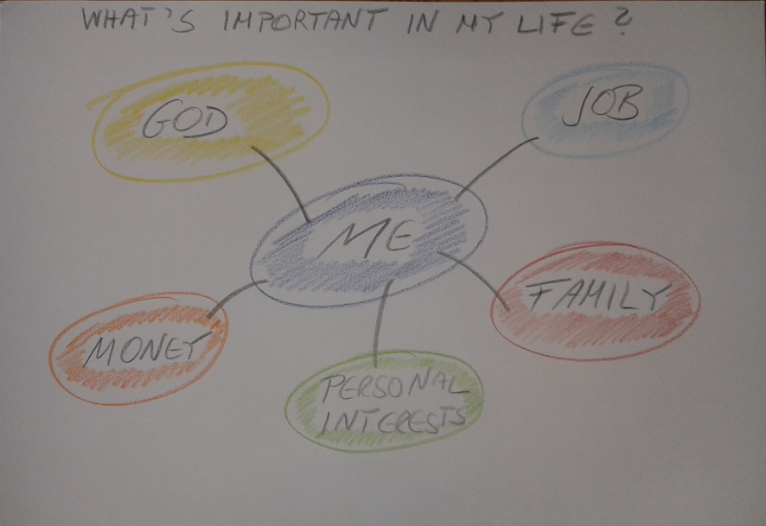
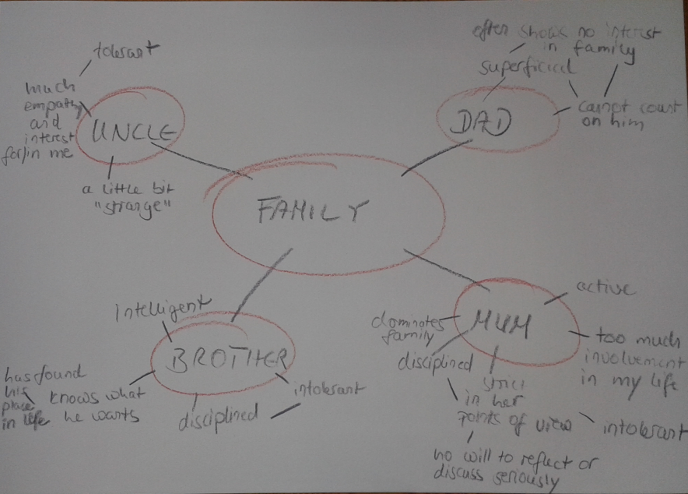 Photographs: Bettina Gröber

2.2 Verbal-associative instruments in healing writing
Expression of thoughts and feelings can use diverse media; in the field of ‘healing writing’ applied in psychological or therapeutic settings, as is said in the introduction of the present text, the focus often lies on forms and means based on visual or musical exercises or the employment of the body, for example trough expressive dancing. But not every patient or person finds an approach to such techniques – and thus, language, whether spoken or written, is the way one gets the chance to confront oneself with what is in one’s mind or soul. Being aware of what was stated on the importance of “inner pictures” in the preceding paragraph, it is not surprising that especially verbal-associative instruments out of the repertoire of writing to learn strategies are often employed for the purposes of ‘healing writing’. The goal is – just as it is concerning graphic-associative methods and exercises – to promote (not rarely an initial) articulation of thoughts, emotions and experiences. Silke HEIMES’ appeal “Schreib es dir von der Seele”, which also is the title of one of her publications, can be taken literally: healing writing in this sense means writing without censorship, anything what’s on one’s mind may be written down – as is the case with freewriting being one of the most prominent methods of writing to learn established by Peter ELBOW:
„Freewriting
The idea is simply to write for five minutes (…). Don’t stop for anything. Go quickly without rushing. Never stop to look back, to cross something out, to wonder how to spell something, to wonder what word or thought to use, or to think about what you are doing. If you can’t think of a word (…) just use a squiggle or else write, “I can’t think of it.” (…) as many times as you want; or repeat the last word you wrote over and over again (…). The only requirement is that you never stop.”
BRÄUER differentiates between freewriting being a writing technique and related methods like “Freies Schreiben” or personal-creative writing and also gives an example for the “healing” use of the former:
“Freewriting ist also nicht, wie beim Freien Schreiben oder personal-kreativen Schreiben, die Produktion eines für sich stehenden Textes, der oft sogar für einen konkreten Leser verfasst wird, sondern Mittel auf dem Weg zu einem Text in einem bestimmten Genre. Ich schlage vor, freewriting als eine Technik zu verstehen, die weder auf ein bestimmtes Ausbildungsgebiet, noch auf ein bestimmtes Genre zielt. (…) Natalie Rogers (…) fordert ihre Klienten zu Beginn des Therapiegesprächs auf, alles, was ihnen in dem Moment der Gesprächseröffnung in den Sinn kommt, aufzuschreiben und das Blatt Papier anschließend in den Papierkorb zu werfen.“
Freewriting thus helps to gain awareness of thoughts and feelings by offering time and space for them to be “freed” by writing them down. This can be helpful to discover one’s own state of mind and soul, but also to approach concrete questions and issues. Therefore, there is also the method of focus(ed) freewriting, which also means uncensored, associative writing, but is dedicated to focus on a specific theme.
At the end of this paragraph, the cited interview partner shall speak. Being asked about her experiences with some kind of freewriting, she told the author of the present text about her personal approach to this instrument:
“I’ve always liked writing – far more than painting or singing, for example. That made the therapy I absolved in a specialized clinic for depressive patients rather difficult for me at first, for there were only courses and exercises involving creative expression by colours or sounds or rhythms. I couldn’t get on with these. So, after some time, I started writing. It was not what one would call a ‘diary’, but I wrote short texts in which I expressed feelings, thoughts, my momentary mood… I followed the impulses the art therapists had given – to deal with my mood by finding some kind of “pictures” for my emotions. It was only that I didn’t paint my inner pictures, but wrote them down.”

2.3 Reflective Practice
As noted in the preceding paragraphs, associative strategies of writing to learn used in the field of healing writing often form the basis for further, more detailed, elaborated and reflective approaches to the writer’s thoughts, feelings and experiences. The place for this kind of deeper and broader reflection often is a personal diary.
According to BRÄUER, a diary is the place or medium for “private discourse”: it aims at documenting, commenting and communicating with oneself. The aspect of privacy is most important in this context: by writing in a safe, private way, the ‘healing writer’ gets the chance to express things without respect to other’s “judgment”. This often is a necessary prerequisite to get oneself (or, being a therapist or other practitioner, the patient or client) initially pronouncing parts of one’s own innermost self. Thus, a diary can become what BRÄUER calls a “treasure box”:
“Gleichgültig, ob es sich auf das Schreiben, Lesen, Lernen oder Leben im allgemeinen bezieht, das Tagebuch ist Schatzkästlein, in dem ich, ganz im Schutz des Privaten, Gedanken und Gefühle aus meinem Inneren herausschreibe und im Prozess des Aufschreibens und Lesens erfahre, was sie mir bedeuten.“
Reflection in a diary can happen in many different ways: in the form of daily completed texts of various length, short paragraphs, even shorter key words, and so on – all according to the choice and preferences of the writer. This approach gives – maybe more than any other method or strategy – way to a really individual and individually resource-based application of writing to learn in the field of healing writing.

2.4 Verbal-structuring approaches
In contrast to the previous instruments, verbal-structuring approaches employed in healing writing mainly focus on a very mindful, rational dealing with one’s own emotions and thoughts. There is a broad range of possible techniques, many of them also known as writing to learn strategies, which can be useful to structure feelings, experiences or ideas in order to be able to handle them or to develop plans and strategies for further acting and reacting. Lists of pros and cons concerning a certain issue or schemes which facilitate analyzing situations or relations (for example a four-field matrix) are only two examples for the benefit writing to learn can have for the writer who aims at getting some kind of overview. The resulting texts, schemes, structured overviews, etc. can be used not only for gaining awareness and knowledge of contexts and connection, but also as a substrate for further reflection and development. The following four-field matrix exemplifies both: a first structured overlook concerning a central question (“staying at home?”) – in the present scheme written in different colours – as well as a basis for additions (pencil-written words and phrases) resulting of further work on the issue.
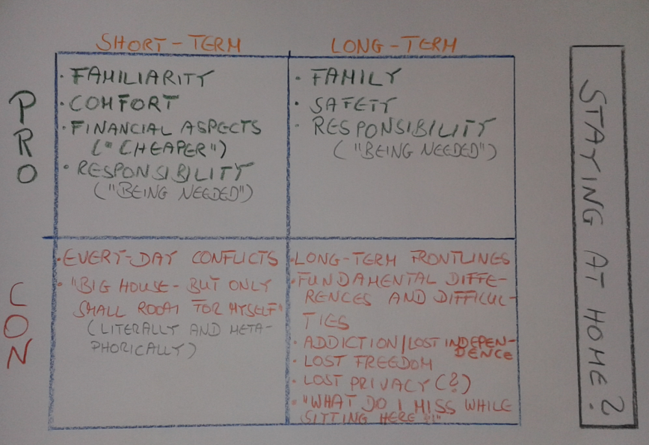 Photograph: Bettina Gröber
- Writing to learn as a way to explore person and personality: An impulse for further elaboration of healing writing instruments by aspects of non-directive writing consulting
As was shown in the previous paragraphs, instruments and strategies of writing to learn allow the writer to gain knowledge about one’s own feelings and thoughts as well as competence in dealing with personal experiences and issues. For James W. PENNEBAKER as well as for many other scientific authors, the potential of writing for health purposes is enormous: “Expressive writing is a self-reflective tool with tremendous power. By exploring emotional upheavals in our lives, we are forced to look inward and examine who we are. This occasional self-examination can serve as a life-course correction.” Writing competence thus can be classified as being part of life competence. Authenticity, individuality and something which can be defined as practical value are promoted, an aspect especially essential concerning healing writing.
Healing writing offers writers help to help themselves in a resource-orientated way – and this aspect connects healing writing with another field using writing to learn for purposes of personal development: in writing consulting, more precisely in non-directive writing consulting, the named principles and values are also fundamental ones. The present text is not the place to explore deeper the potentials and boundaries of mutual influence, but wants to end up by underlining that such a deeper exploration could be beneficial for both sides. While writing consulting could gain further more underlining by keeping in mind the aspect of writing competence as a part of life competence (which healing writing is a most prominent example for), healing writing could get impulses for further development by contents relevant in writing consulting: one could especially think of the distinction between structure-following and structure-creating types of writers (and the variety of types that lies between the two extremes) – a distinction based on very individual characteristics the writer reveals in his or her writing. To take into account questions of writing type therefore could help to develop even more individual strategies and instruments of healing writing.

Bibliography

Works Cited

- Gerd BRÄUER (2003): Schreiben als reflexive Praxis. Tagebuch, Arbeitsjournal, Portfolio. Freiburg im Breisgau: Fillibach-Verlag.
- Gerd BRÄUER (2006): Peter Elbows Konzept des freewriting als Paradigmenwechsel in der amerikanischen Schreibpädagogik. In: Schreiben im Kontext von Schule, Universität, Beruf und Lebensalltag. Berlin: LIT, pp. 11 – 28.
- Gerd BRÄUER (2014): Grundprinzipien der Schreibberatung – abgeleitet au seiner pragmatischen Sicht auf die Schreibprozesstheorie. In: Stephanie DREYFÜRST/Nadja SENNEWALD (ed.): Schreiben. Grundlagentexte zur Forschung, Didaktik und Beratung. Stuttgart: UTB, pp. 257 – 282.
- Bettina GRÖBER: Wenn Papier zum Spiegel wird. Badische Zeitung, 25 September 2017.
- Silke HEIMES (2010/2015): Schreib es dir von der Seele. Kreatives Schreiben leicht gemacht. Göttingen: Vandenhoeck & Ruprecht.
- Ann HUDSON JONES (2006): Writing and healing. In: Lancet Vol. 368, pp. S3 f.
- Ronald T. KELLOGG et. al. (2013): Working Memory in Written Composition. An Evaluation of the 1996 Model. In: Journal of Writing Research, 5(2), pp. 159 – 190.
- James W. PENNEBAKER/John F. ADAMS (2014): Expressive Writing. Words that Heal. Enumclaw: Idyll Arbor.
- ---/Joshua M. SMITH (2016): Opening Up by Writing It Down. How Expressive Writing Improves Health and Eases Emotional Pain. New York: Guildford Press.
- Sondra PERL (2004): Felt Sense. Writing with the Body. München: Heinemann.
- Monika SCHWARZ-FRIESEL (2013): Sprache und Emotion. Tübingen: Narr Francke Attempto Verlag.
- Afra STURM/Andrea BERTSCHI-KAUFMANN (2009): Reading. In: Gerd BRÄUER (ed.): Scriptorium. Ways of Interacting with Writers and Readers. A Professional Development Program. Freiburg in Breisgau: Fillibach Verlag, pp. 27 – 42.

Internet Sources

- https://wac.colostate.edu/resources/wac/intro/wtl/ (page called up on 27 June 2019).
- https://liberalarts.utexas.edu/psychology/faculty/pennebak#writing-health (page called up on 26 June 2019).

See Silke HEIMES (2010/2015): Schreib es dir von der Seele. Kreatives Schreiben leicht gemacht. Göttingen: Vandenhoeck & Ruprecht, p. 11: „Während das kreative und therapeutische Schreiben in den Vereinigten Staaten längst einen festen Platz unter den Ausdruckstherapien wie Malen und Tanzen hat, ist es in den deutschsprachigen Ländern noch am Rande zu suchen.“ The truth of this statement is underlined by the fact that German-speaking academic discourse on the other hand has well considered the close connection and mutual influences of language and emotions (see, for example, Monika SCHWARZ-FRIESEL [2013]: Sprache und Emotion. Tübingen: Narr Francke Attempto Verlag) – obviously, the way from theoretical treatment to practical relevance is a long one.
This is the conclusion the author of the present text draws after having searched the internet and investigated the homepages of a number of psychosomatic clinics (state: June 2019).
https://liberalarts.utexas.edu/psychology/faculty/pennebak#writing-health (page called up on 26 June 2019).
Ibid.
Out of the great number of publications of the US expert for expressive and healing writing, the present text mainly refers to the following books: - James W. PENNEBAKER/John F. ADAMS (2014): Expressive Writing. Words that Heal. Enumclaw: Idyll Arbor. - ---/Joshua M. SMITH (2016): Opening Up by Writing It Down. How Expressive Writing Improves Health and Eases Emotional Pain. New York: Guildford Press.
Compare James W. PENNEBAKER/John F. ADAMS (2014): Expressive Writing. Words that Heal. Enumclaw: Idyll Arbor, chapter 1.
Silke HEIMES (2010/2015): Schreib es dir von der Seele. Kreatives Schreiben leicht gemacht. Göttingen: Vandenhoeck & Ruprecht, p. 16.
By dealing with writing to learn strategies in the field of ‘healing writing’, the present text presents a mental-cognitive focus. For the purpose of this article, aspects of the relevance of the body-mind connection were excluded – but nevertheless not ignored. For a deep insight with practical relevance compare, for example, Sondra PERL (2004): Felt Sense. Writing with the Body. München: Heinemann.
In addition to or before the question of motivation, there is that of general writing competency: the latter is of course essential for the working of healing writing and writing to learn.
In this regard, the question whether or not the writer can adequately communicate and gain comprehension or understanding by others has no importance: “Yet even if all patients were able to tell their stories of illness and find healing through their telling, not all such stories would be told skilfully enough to convey - wisdom and healing to others.” (Ann HUDSON JONES (2006): Writing and healing. In: Lancet Vol. 368, p. S4.
https://wac.colostate.edu/resources/wac/intro/wtl/ (page called up on 26 June 2019).
The graphic designed by the author comprises only the instruments of writing to learn which are treated and cited in the present text. Nevertheless, there are also many other techniques and strategies that can be categorized using the scheme offered here.
The present text is not the place to further develop this thought. For a detailed account of working memory in writing theory see Ronald T. KELLOGG et. al. (2013): Working Memory in Written Composition. An Evaluation of the 1996 Model. In: Journal of Writing Research, 5(2), pp. 159 – 190. – In addition, one also has to be aware of the importance of what is called the “inner text” in writing theory (compare Afra STURM/Andrea BERTSCHI-KAUFMANN [2009]: Reading. In: Gerd BRÄUER (ed.): Scriptorium. Ways of Interacting with Writers and Readers. A Professional Development Program. Freiburg in Breisgau: Fillibach Verlag, pp. 29 ff.). Briefly formulated with regard to the subject of the present article: inner pictures can form inner, cognitive texts – and the latter can find their way into material texts via writing to learn.
The author of the present text owes great thanks to an interview partner who has provided diverse papers and pictures which resulted from a psychotherapy she took several years ago. (Any personal information is treated confidential according to the protection of personal data and privacy.) With respect to the present text written in English, the original papers were translated by the author.
Loc. cit.
ELBOW, Peter [1973/1998]: Writing Without Teachers. London, Oxford, New York: Oxford University Press. S. 3. Cited from: BRÄUER, Gerd [2006]: Peter Elbows Konzept des freewriting als Paradigmenwechsel in der amerikanischen Schreibpädagogik. In: BERNIG, Johannes, u.a. [Hrsg.] [2006]: Schreiben im Kontext von Schule, Universität, Beruf und Lebensalltag. Berlin: LIT VERLAG. p. 3.
Ibid., p. 4.
PENNEBAKER also refers to freewriting in this context and regards it being “a useful practice exercise, and one that can enhance creativity and foster your capacity for expression”. –James W. PENNEBAKER/Joshua M. SMITH (2016): Opening Up by Writing It Down. How Expressive Writing Improves Health and Eases Emotional Pain. New York: Guildford Press, p. 19.
The original interview was conducted for a journalistic article which the author of the present text published in 2017 (“Wenn Papier zum Spiegel wird”. Badische Zeitung, 25 September 2017). Contents have been verified again with respect to the present text in June 2019. As is the case for the illustrating papers used in the present text, also the cited statement, originally made in German, was translated and formatted by the author.
Gerd BRÄUER (2003): Schreiben als reflexive Praxis. Tagebuch, Arbeitsjournal, Portfolio. Freiburg im Breisgau: Fillibach-Verlag, p. 16 (figure 3).
Ibid., p. 20.
The author of the present text once more thanks her interview partner who – with allowing the matrix to be used for this article – has made possible an especially deep insight in her personal issues, thoughts and feelings.
James W. PENNEBAKER/John F. ADAMS (2014): Expressive Writing. Words that Heal. Enumclaw: Idyll Arbor, p. 21.
For the principles of non-directive writing consulting see Gerd BRÄUER (2014): Grundprinzipien der Schreibberatung – abgeleitet au seiner pragmatischen Sicht auf die Schreibprozesstheorie. In: Stephanie DREYFÜRST/Nadja SENNEWALD (ed.): Schreiben. Grundlagentexte zur Forschung, Didaktik und Beratung. Stuttgart:UTB, pp. 257 – 282.

